**COS10025 Technology in an Indigenous Context**

**Semester 2 2022**

**Research Report**

**Project Title:**

Digital Connectivity Infrastructure for Remote Indigenous Communications

**Project Team:** Group 3

**Year:**  2022

**Project Principal/facilitator**:

Name: Dr. Kaberi Naznin

Role: Workshop Facilitator

Workshop Sessions: Friday (10:30 am - 12:30 pm), EN406

Email: [knaznin@swin.edu.au](mailto:knaznin@swin.edu.au)

# Table of Content

Contents

Table of Content 2

1 Literature review 2

2 Project background 4

1.0 Project Description 4

1.1 Problem Statement 4

2 Project Goals and Objectives 5

3 Desired outcomes and benefits 5

4 Learning issue/problem (individual) 6

5 Project Scope and Exclusions 7

6 Project Deliverables 7

Project Management Plan 7

# Literature review

In this part I’m going to share some of the research that had been done by some Well-known Researcher about Indigenous people around Australia, specifically in Bamaga, Cape York, Queensland.

1. Prior to the advent of communication technology in recent years including mobile technology, the majority of Australia’s Indigenous people had little ICT.V usage. Numerous research supported Indigenous people's low rates of private adoption of fixed-line phones, computers, and the internet (DBCDE 2012; DCITA 2002; RTIRC 2008).

Research conducted for the Wujal Wujal Aboriginal Shire Council on the adoption and use of mobile technology by an Aboriginal community in Cape York. The introduction of a Telstra 3G mobile phone network in January 2008 marked a significant shift in the way that this community in the Cape was able to access information and communication technology (ICT).

Senior lecturer in information technology at the University of Technology, Sydney is Laurel Evelyn Dyson (UTS). She holds a doctorate from the University of Sydney as well as an M.Sc. in IT from UTS. Her study focuses on mobile learning and Indigenous people's usage of ICT. She has taken part in the Indigenous Pre-IT Program, the UTS Indigenous Participation in IT Program, and the UNESCO ICT for Intercultural Dialogue Project. She co-authored the book Information Technology and Indigenous People, among other works (Information Science Publishing, Hershey, PA, and London, 2007). [5]

1. Numerous Australian government initiatives have been in place since the late 1990s with the goal of bringing IT resources, internet connection, and training to isolated Indigenous communities (RICs). 3.3% of Australia's overall population, or about 798,365 Aboriginal and Torres Strait Islander people, were estimated to live in remote Indigenous communities and homelands in 2016.
2. Generations of editors and contributors to Britannica have described the Aboriginal and Torres Strait Islander peoples of Australia in accordance with the editorial standards and cultural norms of their time, as well as their own personal consciences, since the Encyclopaedia Britannica's first articles were published in 1768. This led to a long tradition of vocabulary and usage habits that, far too frequently, were callous to the peoples being portrayed and conveyed the writer's—and the writer's culture's—racialist notions and imagination.

Britannica has therefore established the following criteria:

If a person is descended from an Aboriginal person, self-identifies as an Aboriginal person, or has been acknowledged as an Aboriginal person by their community, the terms "Aboriginal people" and "Aboriginal person" should be used to refer to them. The word "Australian Aboriginal" is allowed when referring to a situation in Australia.

People of Torres Strait Islander descent who self-identify as such or who have gained such recognition from their own community should be referred to as "Torres Strait Islander people" and "Torres Strait Islanders," respectively.

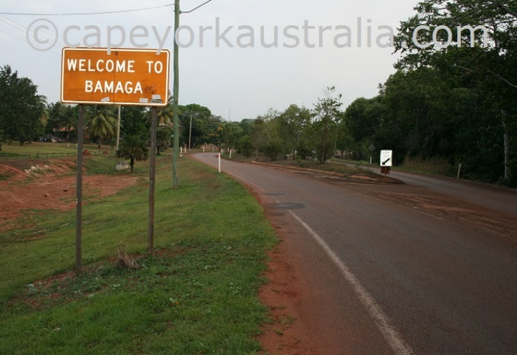

Near the tip of Cape York, Bamaga serves as the administrative hub for the Northern Peninsula Area (NPA). The biggest township north of Jardine River is this one. It serves as the administrative hub for the Northern Peninsula Area due to its size as the largest community (NPA). [(York, 2018)]

It is a Torres Strait islander community, not an Aboriginal comparable to the neighbouring Injinoo and Umagico. About 3,000 people live in the five villages that make up Queensland's Northern Peninsula Area (NPA), which includes the Islander settlements of Seisia and Bamaga as well as the three Aboriginal communities of Injinoo, Umagico, and New Mapoon**. Traditional Owners of Bamaga are Anggamuthi, Atambaya, Wuthathi, Yadhaykenu and Gudang.** The Department of Native Affairs moved the Saibai islanders to this remote hamlet just after World War II, and their chief, Bamaga (Bamaga Ginau, 1893–1949), went by that name. [2]

The Bamaga Township was relocated to its current location in 1947 because the original inhabitants need a larger source of fresh water. Originally it was a community of **Saibai islanders** - right from the northernmost Torres Strait. [3]

There were 1,164 people living in Bamaga as of the 2016 census, and 957 (82.4%) of them self-identified as being of Aboriginal or Torres Strait Islander descent. Currently, there are around 75% Islanders and 20% Aboriginal people living there. [(*Bamaga, QLD*, n.d.)]

# Project background

## Project Description

Numerous Australian government initiatives have been in place since the late 1990s with the goal of bringing IT resources, internet connection, and training to isolated Indigenous communities (RICs). Around 19% of the estimated 798,365 Aboriginal and Torres Strait Islander people in Australia in 2016 lived in remote Indigenous communities and homelands, making up 3.3% of the country's total population.

While isolated settlements vary in size, population, distance from regional centres, services offered, and social, cultural, and historical influences, many Indigenous Australians living there have particular needs and difficulties. Numerous of these issues are well known and well-documented, such as low socioeconomic conditions, few opportunities for training and employment, a lack of key services (banks, libraries, hospitals, post offices, youth services, childcare, and legal support), high living expenses (food, fuel, and services), and a scarcity of food (especially fresh fruit, vegetables and meats).

There is range of factors that can significantly impact on the uptake and effectiveness of communication technologies and services. This project is focused on analysing current challenges, needs for communication technologies, and services for remote Indigenous communities around Australia.

## Problem Statement

Bamaga, Cape York, has some early telecommunications infrastructure, but phone and internet service providers are abandoning this area, leaving its residents with less coverage.

To further explain, service providers like Optus and Telstra must expand their coverage to 4G and 5G, enabling not only the residents of the town to use a reliable network but also any possible visitors who might be interested in visiting Bamaga. The local government must take some steps to come with a proper solution to solve this problem.

With hundreds of kilometres of its primary thoroughfare, the Peninsula Development Road, unconnected, the lonely Cape has highly patchy cell phone reception.

# Project Goals and Objectives

The Team's ultimate objective is to find a workable solution to the technological problems that the town of Bamaga has encountered. Every team member should aim to finish and turn in each of their assignments on time and to a high standard in order to contribute to this goal. Each time the group completes and turns in an assignment, a milestone is accomplished.

These accomplishments ought to be noted, and team members ought to congratulate one another on a job well done. This should motivate each team member to continue giving all their effort to upcoming responsibilities.

# Desired outcomes and benefits

The development of solutions about how we could possibly expand the already constrained communications system in Bamaga, Cape York, is a key goal that our group is working towards.

As a group, we hope to educate the indigenous Australian people living in Bamaga about digital infrastructures and what a better telecommunications system can provide them. By doing so, the townspeople will be more willing to accept technology in their culture rather than hindering. This will further allow them to use this technology in all mediums, such as a news, health, education and finance.

Less on the actual problem description, desired goals and benefits refer to our understanding of Indigenous Australian townships. As we work on this project, we'll also try to educate ourselves on the difficulties that Indigenous Australians face because their living conditions are different from those of the rest of the country. Additionally, we could learn how to apply their current ideologies and systems to our own lives.

# Learning issue/problem (individual)

In this part, I will discuss about the current telecommunication systems of Bamaga, environmental health and what are the issues with them.

1. There is only one Telstra fibre optic cable that connects Cairns to the Torres Strait, and there is no redundancy in case of breakage or other outages due to other factors. In the past, rodent damage to the fibre cable caused communication services to be unavailable for weeks in the upper portion of Cape York and the Torres Strait.

2. Telstra has not responded to Cape York Weekly or given the locals any explanations on why it consistently fails in the area.

3. Owners of a rural roadhouse in Cape York are using their own technology and spending tens of thousands of dollars to upgrade a deadly blackspot in order to gain mobile reception. According to them during Cyclone time they don’t have any internet service.

⬩ Most of Cape York lacks phone or internet service.

⬩ The Archer River Roadhouse's owners are developing their own mobile tower.

⬩ According to a communications company, more companies are choosing to construct their own towers.

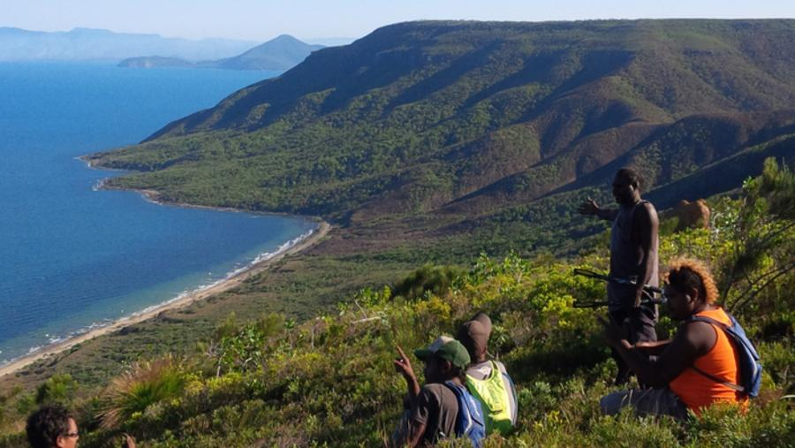

Remote Cape York, where mobile reception is rarely available.

4. In Queensland's extreme north, on Cape York Peninsula Land clearing for pastoralism, which frequently involves burning, mining, as well as excessive use and contamination of streams pose threats to the area (Ockwell and Rydin 2006, Schneiders 2006).

# Project Scope and Exclusions

In this part We will discuss about what can be done as solutions of those issues, but we will not jump into the solutions, but we will share what are the steps and measures can be taken.

1. The area's current telecommunications solutions must be improved by new offerings.

These could consist of backhaul capacity improvements to enhance service quality,

upgrades to solve seasonal congestion, or more mobile towers in locations with spotty coverage.

2. Applications must show their ability to deliver, co-investment, and economic and/or social advantages.

# Project Deliverables

The main topics that fall under the purview of our study are telecommunications and digital infrastructure research. This will include the concepts for potential solutions that we come up with after investigating our learning problems.

The engineering of the solution is an example of an exclusion, or area that will be outside the scope. It would be outside the scope to develop the hardware and software to make a gadget that the residents of the town would install in their homes, for instance.

# Project Management Plan

Our timeline will be heavily based off the one provided by the Unit Convenor on Canvas. It is as follows:

Phase 1: Week 1 -3

* Team formation and Role selection
* Task, document, and project management formation/document creation
* Brainstorming the project objectives and selecting your innovative design

Phase 2: Week 4 – 6

* Complete a design model and get comments.
* Become knowledgeable about a selected platform and potential developments
* Begin creating the prototype with your team.

Phase 3: Week 7 -9

* Design and development progress on the prototype (application)
* Evaluation of your prototype

Phase 4: Week 10 – 12

* Design prototype testing and re-design
* Project presentation and demonstration

**Development of our Prototype:**

▪ Collate findings from each team members learning issues

▪ Brainstorm three potential solutions

▪ Aim to submit these solutions for feedback by week 8

**Evaluation and presentation of our prototype:**

▪ Based on Feedback in Week 8, amend potential solutions.

▪ Aim to finish final solutions by week 11, ready to demonstrate and submit

**Team Breakdown and Duties**

Our group is called "Group 3". Very original. Our team member and their corresponding duties are as follows:

▪ James Kojdovski (103989717) - Team Leader (organizing events, maintaining project management systems, and contributor to group project)

▪ Elijah Roberts (104002152) - Secretary (assisting team leader, dedicated workshop

note-taker, contributor to group project)

▪ Md Nahid Tanjum (103807068) - Member (contributor to group project)

▪ Kayes Ahmed Koushik (103832293) I Member (contributor to group project)

▪ Shreeya Shrestha (103831863) - Member (contributor to group project)

▪ Moriom Rahman (103486807) - Member (contributor to group project)

#### **References**

1. <https://www.capeyorkaustralia.com/bamaga.html>

2. <https://www.exploroz.com/places/28613/qld+bamaga>

3. <https://www.indigenous.gov.au/community/bamaga>

4. <https://www.aussietowns.com.au/town/bamaga-qld>

5.<https://openresearchrepository.anu.edu.au/bitstream/1885/59842/4/02_Kral_The_acquisition_of_media_as_2013.pdf>